# Goal

In this assignment we are going to try to create a simple contact list page.

The result should look something like this:

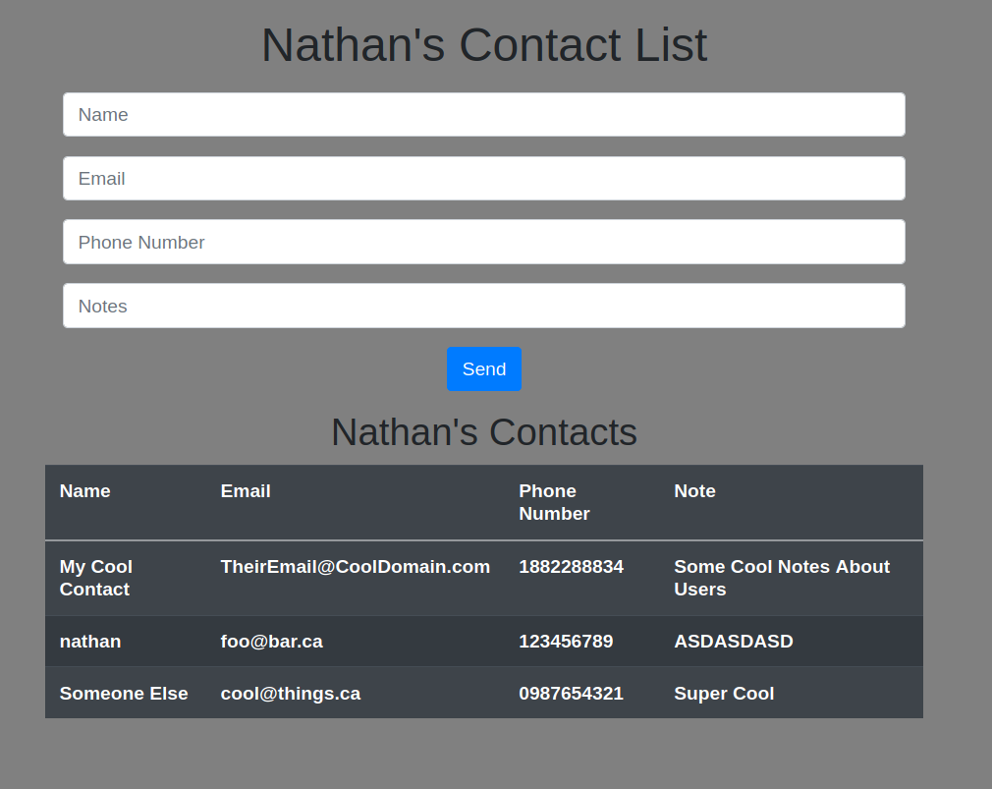

This will require that you create:

1. A simple page with a form that submits at a minimum the following into a database
   1. Name
   2. Phone Number
   3. Email
   4. Notes
2. It should then print out any contacts in the database into a table on the page.

## Bonus

If you finish early, try to create a more complicated database and improve the look of the website.

# General Instructions

## Create the HTML/CSS

1. Create the layout
2. Create the form and inputs for the form
3. Ensure that the form points to the PHP/NodeJS script

## Create the Database

1. You will need to create
   1. A new database
   2. A new user for the database
   3. A new table within the database for the contacts
2. You will need to allow the user access to the database and remember to flush privileges!

## Create the PHP/NodeJS

1. You need to have a PHP or NodeJS script
   1. that inserts the data into the database
   2. that gets all the data from the database and prints it into the table

## PHP Functions/Variables You May Need

// MYSQL FUNCTIONS //

mysqli($server, $username, $password, $database);

prepare();

bind_param();

execute();

fetch_assoc();

close();

// FORM FUNCTIONS and VARIABLES //

isset();

$_POST

$_GET

// Redirecting Pages

header();

## NodeJS Functions/Variables You May Need

require('mysql2');

require('express');

require('path');

app.use(express.static(path.join(__dirname, 'public')));

app.use(express.urlencoded());

app.listen(port)

app.get()

app.post()

mysql.createConnection({host, user, password, database});